Kol Simcha Torah Gazette
For parsha shelach 5785
Volume 9 Issue 38 (Whole #453) 25 Sivan 5785/ June 21, 2025
Printed L’illuy nishmas Nechama bas R’ Noach, a”h
For a free subscription, please forward your request to keren18@juno.com
Past emails can be found on the website ShabbosStories.com under Brooklyn Torah Gazette

What Did Miriam
Say About Moses?
By Mordechai Rubin

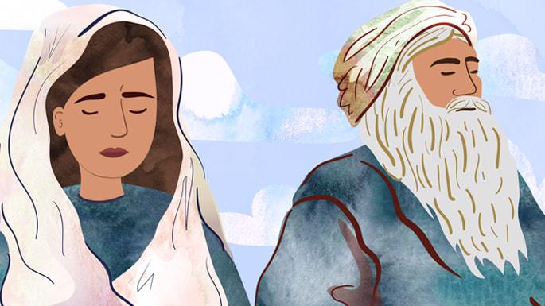
Art by Sefira Lightstone

Parshat Behalotecha concludes with the infamous episode of Miriam and Aaron talking about Moses behind his back:
Miriam and Aaron spoke against Moses concerning the Cushite woman he had married, for he had married a Cushite woman. They said, ‘Has the L-rd spoken only through Moses? Hasn’t He spoken through us too?’ And the L-rd heard.”1
This passage, however, leaves many questions unanswered. Who exactly was this Cushite woman? What did Miram and Aaron say and what was their intent? And how does whatever was said connect to the fact that G-d spoke to Miriam and Aaron, not just Moses?

1. She Was Talking About Tzipporah
Most commentators, including Rashi, explain that Miriam was speaking about Tzipporah, Moses’ Midianite wife. The term “Cushite” is not literal; it’s a euphemism for beauty—just as a person of obvious complexion is universally recognized, so was Tzipporah’s beauty.
Miriam discovered—by overhearing Tzipporah’s lament—that Moses had separated from his wife in order to maintain prophetic readiness. She questioned this decision: “Why has Moses withdrawn from his wife? G-d also speaks with me and with Aaron, yet we remain with our spouses.” Rashi emphasizes that even though she was motivated by concern and her words were not intended as an insult, since it involved discussing Moses’ private life without his knowledge, G-d rebuked them.2
Baal Haturim adds that the Hebrew word "הכושית" (“the Cushite”), has the same numeric value (gematria) as the phrase "יפת מראה", which translates as “beautiful of appearance”—both totaling 736.

2. Miriam Accused Moses of Separating
From His Wife Because She Was a Convert
Rabbi Naftali Zvi Yehuda Berlin (known by the acronym Netziv) suggests that Aaron and Miriam assumed that Moses had separated from her because, in their view, it was beneath his dignity to remain married to someone not from distinguished Israelite lineage. They argued that this was inappropriate since Moses had willingly married her, knowing her background. She hadn’t deceived him, so it was wrong for him to now cause her pain by separating from her.3 However, the real reason he separated was to maintain an appropriate state of readiness to converse with G-d “face to face.”4

3. Miriam Was Referencing a Cushite Wife
Moses Had Taken Years Earlier
Rashbam, who explains the “plain meaning” of these verses, understands the Cushite woman mentioned in the verse not as a reference to Moses’ wife Tzipporah, but a Cushite queen he married during the 40 years he ruled in Cush, as described in Chronicles.
Miriam was critical of the fact that he had taken this woman as a wife. However, Moses never had relations with her, and Miriam and Aaron were unaware of this when they spoke about him. This explanation fits the plain meaning of the verse, since if the complaint were about Tzipporah, there would be no need to introduce her as a “Cushite”—we already know she was a Midianite. Moreover, Tzipporah could not accurately be called a Cushite, as Midian descended from Keturah, the wife of Abraham, whereas Cush descended from Cham.5
This is similar to Bechor Shor’s reading, who articulates Miriam’s complaint: “Was there no woman among the daughters of Israel for Moses to marry, that he went and took a wife from among the Cushites, who are uncircumcised? Is it because G-d speaks with him that he holds himself above others—too proud to marry a Jewish woman, seeking instead a wife from afar?”
He explains that the fact that Moses married Tzipporah, who was also not from the descendants of Jacob, was not something to be criticized, as he had no control over those circumstances. He had to flee Egypt to Midian after Pharaoh sought to execute him and was therefore not able to marry a woman of Jewish descent.6

4. She Was Criticizing the Fact That He
Married Tzipporah in the First Place
Some commentators,7 while agreeing that the criticism was not about Tzipporah’s appearance or character, understand it as questioning how Moses—Israel’s greatest prophet—could have married a foreign woman at all. These views draw on the earlier tradition that Moses once married a Cushite queen, but apply that critique instead to Tzipporah, his Midianite wife. In this reading, Miriam and Aaron weren’t criticizing Moses for separating from his wife, but for marrying someone not from the daughters of Israel in the first place.

5. It was Not What She Said
In a complex talk exploring Rashi’s explanation for the juxtaposition between this episode and the disastrous mission of the Spies that immediately follows, the Rebbe uncovers the core of Miriam’s error.
Her mistake was not that she wished to speak ill of her brother Moses, as Rashi points out: “She did not intend to speak negatively about him.”8
So, what, then, was her wrongdoing? The issue, as Rashi explains, was that she was “involved in speech”—she was punished simply for speaking about her brother at all. If Miriam observed something in Moses’ conduct that troubled her, the proper course of action was not to discuss it with someone else. Such conversations rarely lead to a constructive outcome. If she truly had a concern, she should have addressed it—discreetly and directly—with Moses himself.9

Footnotes
1. Numbers 12:1–2.
2. Rashi Numbers 12:1.
3. Baal Haturim Numbers 12:1.
4. Netziv Numbers 12:1.
5. Rashbam
6. Bechor Shor Numbers 12:1.
7. See Moshav Zekenim, Radak, Tur, Numbers 12:1.
8. Rashi Bamidbar 12:1.
9. Likkutei Sichot vol 18 p 147.

Reprinted from last week’s website of Chabad.Org

Rav Avigdor Miller
On Golden Silence
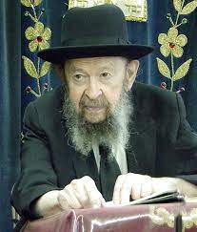

QUESTION: How does a yeshiva bochur refrain from hearing loshon hara in his dormitory room?
ANSWER: He should walk out of the room until the people go to sleep. Let him sit in the beis hamedrash until his chaveirim go to sleep. And in case they don’t go to sleep until late, he should tell them, “Chaveirim, please excuse me. I have to go to sleep and when you talk I can’t sleep; do me a favor, please.”
Ask rachamim, mercy, from them, and then you go to sleep so that way you won’t hear loshon hara and you’ll also be able to get up for davening the next morning on time.
Rabeinu Yonah gives an eitzah like this: He says that when you hear loshon hara and you’re not able to rebuke the people – for some reason you can’t give them reproof and tell them it’s loshon hara – so at least don’t show any interest. Show a sad face, he says, an uninterested and bored face, and that will discourage them.
He brings a possuk: – “An unhappy face will dispel the false tongue” (Mishlei 25:23). If you show an unhappy face, that might quiet him down. But if you show an interested face – he’s talking to you and you show an interested face, a lively face – it means you’re encouraging him, “Keep on, keep on talking.” And he’ll keep on pouring loshon hara into your ear. But if he sees that you’re discouraged, you’re not interested, that will stop him from talking loshon hara.
So, let’s say there’s somebody in your house talking about something and you don’t want to talk. They’re wasting your time. Let’s say, it’s not even loshon hara, but it’s devorim b’teilim, idle chatter. So, if it’s possible to show that you’re not interested in a way that wouldn’t insult him, then that will help to stop it.
Sometimes however, when the person is not talking loshon hara, it’s a mitzvah to let that person talk. Many times, for some people of lower character, talking a good deal helps them to feel happy. So, if you’ll lend them your ears just as a donation, in order to let them relieve themselves, it’s a mitzvah as long as there’s no loshon hara involved.
The truth however is, that it’s impossible. ברוב דברים לא יחדל פשע – “When many words are spoken, you cannot avoid loshon hara, that’s for sure” (Mishlei 10:19). So sooner or later, something will come up that’s forbidden. Therefore, it’s always better not to talk much.



When you look at your children and see the ones that don’t talk much, it’s a ma’alah, a good quality. And your grandchildren too. I look around at my grandchildren and I admire some of them, I love some of them very much – the boys and girls who don’t talk much. It’s a very big ma’alah. They’re intelligent, but yet they don’t have the habit of opening their mouths and talking. It’s a midah tova ad me’od, an exceptionally good quality.
And the gemara says it’s a sign of aristocracy, of good yichus. שתיקותא דבבל היינו יחוסא – “In Bavel silence was always a sign of aristocracy” (Kiddushin 71b). If they wanted to marry into a family, and they wanted to know if it was a good family, so they couldn’t always investigate their antecedents, their ancestors. So, what did they do? If they saw that it was a person who didn’t talk much, or his family didn’t talk much, so they surmised that it must be a good family, a family of good pedigree. In Bavel that’s how they judged: שתיקותא דבבל היינו יחוסא – Silence, that was their pedigree.
And so, in general, if you want to make a good impression, keep your mouth closed. I wrote a poem once:
In lion’s skin an ass did hide
And none could know who was inside
Until himself he did betray
By opening his mouth to bray

That’s an Aesop’s fable. A lion once left his skin on the road, and a donkey came along and found this lion-skin. So, this donkey thought, “Oh, what an opportunity! I can wear the lion-skin and now people will be afraid of me!” So, he put on the lion-skin to make himself look like a lion, and everybody was afraid of him. He was so happy! He was so excited that he opened his big mouth and he brayed. And now all the animals in the forest realized:
“Oh,” they said, “It’s nothing but a donkey!”
So, they took their sticks and beat him over the head.
And so, you’re a good-looking young man, your face is tzelem Elokim – I’m looking at you right now and you make a good impression on me. You’re a good-looking girl, a nice decent girl. Open up your mouth however, and you bray, and now you spoiled the whole thing! That’s why silence is golden – silence makes you look better.

Reprinted from a recent email of Toras Avigdor based on a Thursday night lecture (Tape #910)

A Jew’s Involvement in Mundane Entanglements
Are Part of the Divine Plan
From the Teachings of the Lubavitcher Rebbe
Rabbi Menachem Mendel Schneerson, Zt”l



This week's Torah portion, Shelach, relates the story of the spies sent by Moses to investigate the Holy Land which the Jewish people were to enter. They returned with a slanderous report, playing up the difficulties in conquering the land, thus discouraging the people and weakening their faith. This led to the tragic consequences related in the portion.
Chasidism explains that the spies did not wish to enter the Land of Israel because they did not want to become involved with the materialism of the world. Throughout the duration of the Jewish people's stay in the desert, they were free from such involvements: their food came from heaven (the manna); water they had from the miraculous "Well of Miriam"; they were sheltered by the Heavenly "Cloud of Glory." Thus, they did not wish to leave the desert to enter the Holy Land where they would have to engage in ploughing, sowing, and all other normative activities for their daily existence.
The spies' motive may have been sincere and spiritual, but it went counter to the Divine intent. G-d created the world in order to have a Divine abode in this physical world: man is to transform himself and the material world into a worthy abode for G-dliness. This is done by utilizing and interacting with every created substance for its Divinely intended purpose, thus elevating and sublimating it to a spiritual reality. That is why we were given the Torah and mitzvot (commandments), which enable us to achieve that goal. And that is our mission for the duration of the exile.
The Messianic era is the ultimate purpose of the creation. For then this physical world will demonstratable be a Divine abode, with G-d's Presence fully manifest and experienced. It will be a time of "neither famine nor war, neither envy nor strife, because good will emanate in abundance and all delightful things will be accessible like dust.
The singular preoccupation of the entire world will be to know G-d. The Israelites, therefore, will be great sages and know the hidden matters, attaining knowledge of their Creator to the full extent of human capacity, as it is said: "The earth shall be full with the knowledge of G-d as the waters cover the sea" (Isaiah 11:9) (Hilchot Melachim 12:5).
This ultimate perfection of the Messianic era and the time of the Resurrection of the Dead depend on our actions and service of G-d throughout the duration of the exile. The sin of the spies was that they tried to circumvent the process of this refining of the physical world and preparing it for Moshiach.
Mundane entanglements, involvement with worldly matters, may be tiresome and distasteful for one who aspires to spiritual heights. They are, however, an integral part of the Divine plan, and as Chasidism explains: "The ultimate intent of the descent and exile is to prepare for an immense ascent when, in the days of Moshiach, the light of G-d will radiate in a manifest way!"

Reprinted from the Shelach 5762/2002 edition of L’Chaim. From Living with Moshiach by Rabbi J. Immanuel Schochet, adapted from the works of the Lubavitcher Rebbe

Thoughts that Count
for Our Parsha

Visiting the iniquity of the fathers upon the children (Num. 14:18)
G-d lessens the iniquity of parents whose children behave righteously. In their merit, G-d forgives the parents their sins. (Haketav Vehakabala)

Everyone a ruler ("nasi") among them (Num. 13:2)
The Hebrew word "nasi" is composed of the words "ein" ("nothing") and "yeish" ("something"). A Jewish leader who is humble and considers himself "nothing" is the only kind of leader who is truly "something." Likewise, one who thinks he is "something" is not a leader at all. (Degel Machane Efraim)

And we were in our own sight as grasshoppers, and so we were in their eyes (Num. 13:33)
Relating how they were perceived by others was actually one of the sins of the spies. Reporting that they felt "as grasshoppers" is one thing, but saying that the feeling was mutual was another. For one should not care about this at all... (Rabbi Menachem Mendel of Kotzk)

You shall offer up the first part of your dough for a gift (Num. 15:20)
The commandment to separate a portion of dough teaches an important principle in the education of our children: The "first part" of the school day, i.e., the morning hours, should be utilized as a "gift" for "offering up" - set aside for studying holy Jewish subjects, as opposed to secular ones learned later in the afternoon. (The Lubavitcher Rebbe)

Only rebel not against G-d (Numbers 14:9)
Nothing in the spies' report encouraged open rebellion against G-d. On the surface, they were merely reporting facts. Nonetheless, Caleb and Joshua responded by cautioning them not to rebel. For the fear they expressed regarding the land's giant inhabitants and walled cities was what constituted their rebellion. As King David states in Psalms, "G-d is with me; I will not fear what man may do to me." Believing in G-d causes a person to cease fearing man. (Rabbeinu Bechaye)

Reprinted from the Shelach 5762/2002 edition of L’Chaim.
A Father’s Day Story
Like No Other
By Debbie Gutfreund

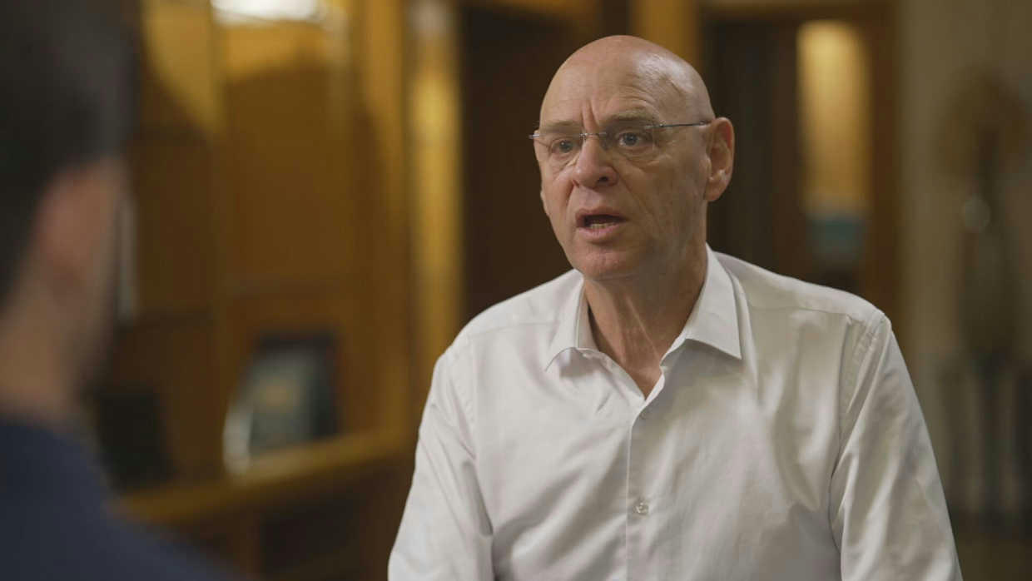

On October 7th, Noam Tibon didn’t wait for help—he became it. This Father’s Day, discover five powerful lessons in love, courage, and what it means to show up when it matters most.
On the morning of October 7th, retired commander Noam Tibon and his wife were swimming off the coast of Tel Aviv when they heard the first rocket siren echo above them. At first they thought it was an isolated incident that would be intercepted soon enough by the Iron Dome, so they continued swimming. But then more sirens began to sound, one after another, and they sensed something was wrong.
Soon after that, they began receiving messages from their son, Amir, who was sheltering in a safe room in Kibbutz Nachal Oz with his wife and two toddler daughters: “Dad, there are terrorists right outside our house. They may even be inside.”
Noam ran home with his wife and grabbed his pistol. His wife offered to drive so that he could message contacts he had in the military on the way there. But no one he called knew how to help. Somehow, he knew that he was his son’s only hope.
As his son Amir wrote in his book Gates of Gaza: “Five minutes later, at approximately 8:30am, the connection briefly returned and I got another call from my father. “Don’t get out of the safe room, no matter what,’ he said. I could hear that he was speaking from inside a car and that it was in motion: ‘We’re coming to get you out of there.’
Noam Tibon’s heroic journey to rescue his family and save countless lives along the way demonstrates the values of a Jewish father.
This Father’s Day, let’s learn from the five values manifested by Noam Tibon and by all of our fathers who have sustained our lives and our families until this day.

1. My family is my life.
Noam was laser focused on his mission of getting to Nahal Oz to rescue his family. He doesn’t remember having many thoughts as he pushed forward to reach his son and grandchildren. But every now and then, even as he was speeding down south and shooting at terrorists, he would have the thought: How will I continue living if when I get there, my family is murdered? How will I go on?” As Noam Tibon said in countless interviews after October 7th: “This is the instinct of every father and grandfather: You will do everything to save your children. Your family is everything.”

2. Shortcuts can be dangerous.
When Noam arrived at his family’s house in Nachal Oz, he finally told the soldiers with him that this was his son’s house. Before that he had been systematically going house to house with the group of soldiers, clearing every house of terrorists. He shared his expertise as a commander with the young soldiers by his side, but he did not rush first to check on his children and grandchildren.
In numerous interviews, Noam explained that every single life in every single house on that kibbutz was precious, and according to his values, he could not prioritize his own children over someone else’s children.
He explained that in life, shortcuts can be dangerous. And in a war, shortcuts can simply kill you. They had to start at the edge of the kibbutz and work their way toward his son’s house, so that they weren’t surprised by terrorists behind them. They needed to follow a system and stick to it as a team. When you take a shortcut, you can lose everything.

3. You Don’t Leave Anyone Behind.
On his way to rescue his son, daughter-in-law and his granddaughters, Noam turned around twice. The first time was when he was approaching the border, and he and his wife saw a couple from the Nova festival standing terrified in the middle of the road. This was right beside a shootout occurring between the Israeli police and a Hamas vehicle full of terrorists. Noam and his wife knew immediately that if they didn’t help this couple, the wife and husband (who also were parents themselves of young children) would be killed.
Without even speaking to each other about the decision, they drove the couple a half hour in the opposite direction to save them.
And when Noam was finally, an hour later, one kilometer away from Nachal Oz, a soldier fighting beside him was shot in the stomach: “I knew from experience, that this soldier needed to get to a hospital within an hour to survive. I was so close to getting to my children and grandchildren. But deeper within me, I knew: You don’t leave anyone behind. This soldier, barely 18 years old, was also someone’s son. So, I turned around for the second time that day. And that is what I am most proud of when I look back on that day. A Jewish father has compassion for everyone’s children. They never leave anyone behind.”

4. When You Are Afraid, You Find a Way.
When Noam was asked how he and his son Amir, locked in a dark room with his tiny daughters who had not eaten or seen daylight for hours, did not panic, he spoke about the challenge of fear: “Most people freeze when they are afraid. And we are all afraid when we face horrific scenarios like October 7th. But you do have a choice when you face that fear. And my wife and I chose to find a way.”
Whether it was crossing a field in their jeep to bypass a military checkpoint or driving fearlessly down ambushed roads to save fellow Jews, Noam and his wife did not freeze. And within kibbutz Nachal Oz, Amir and his wife Miriam were also afraid as they heard terrorists shooting right outside their shelter door. But they had two toddler daughters beside them, and they could not freeze.
Instead, Amir recalls: “I decided to make a promise to Carmel and Galia – and condition it on their behavior. Both of them were mature enough to understand the give-and-take dynamics of such a deal: If you behave, you’ll get to watch television after dinner, always worked on them. This time, though, the promise wasn’t mine to keep, and I could only hope it wouldn’t turn out to be a false one. I took a deep breath and said: “Girls, if we all stay quiet, then Saba will come and get us out of here.”

5. I’m here.
When Noam Tibon finally arrived at his son’s house and knocked on the steel window of the shelter, all he said was: “I’m here.” And as Amir recalls in his book Gates of Gaza: “When we heard my father’s voice on the other side of the safe room window, Galia was the first to speak up. She said simply, ‘Saba is here’… I could hear the exhaustion in her voice – she had been overwhelmed by the events of the day – but at that moment, she also sounded for the first time in hours, happy. My father stepped into the doorway and embraced me. For at least five seconds, we stood there silently, holding each other.”
As we celebrate fathers across the world this Father’s Day, let’s keep in mind those three words that aptly represent the role of a Jewish father: “Sabba is here.”
Reprinted from the current website of aish.com

